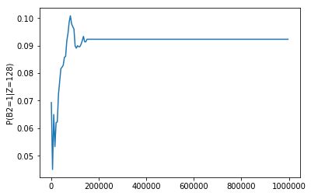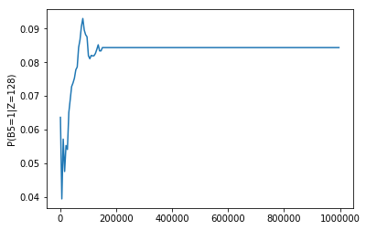

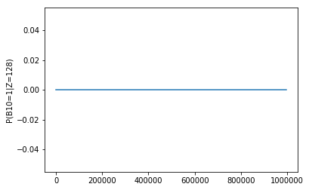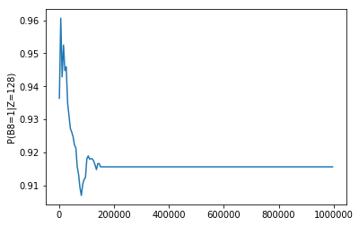

source code:

import numpy

import random

import matplotlib.pyplot as plt

def generate_sample(index):

row_sample=[]

row_size=10

for i in range(row_size):

row_random=random.random()

if row_random<0.5:

row_sample.append(0)

else:

row_sample.append(1)

decimal=int("".join(str(x) for x in row_sample),2)

row_sample.append(decimal)

prob=0.9/1.1*0.1**abs(128-decimal)

row_sample.append(prob)

return row_sample

def sum_of_prob(data):

sum_of_number=0

for i in range(len(data)):

sum_of_number+=data[i][11]

return sum_of_number

total_sample=[generate_sample(d) for d in range(150000)]

sample_num=list(range(1000,1000000,5000))

def diff_number_sample_2(sample_number):

sample=total_sample[:sample_number]

denominator=sum_of_prob(sample)

sample_2=[sample[i] for i in range(len(sample)) if sample[i][8]==1 ] #sample which B2=1

numerator_2=sum_of_prob(sample_2)

result_2=numerator_2/denominator

return result_2

final_result_2=[diff_number_sample_2(d) for d in sample_num]

print(final_result_2[-1])

plt.plot(sample_num,final_result_2)

plt.ylabel('P(B2=1|Z=128)')

plt.show()

def diff_number_sample_5(sample_number):

sample=total_sample[:sample_number]

denominator=sum_of_prob(sample)

sample_5=[sample[i] for i in range(len(sample)) if sample[i][5]==1 ] #sample which B5=1

numerator_5=sum_of_prob(sample_5)

result_5=numerator_5/denominator

return result_5

final_result_5=[diff_number_sample_5(d) for d in sample_num]

print(final_result_5[-1])

plt.plot(sample_num,final_result_5)

plt.ylabel('P(B5=1|Z=128)')

plt.show()

def diff_number_sample_8(sample_number):

sample=total_sample[:sample_number]

denominator=sum_of_prob(sample)

sample_8=[sample[i] for i in range(len(sample)) if sample[i][2]==1 ] #sample which B8=1

numerator_8=sum_of_prob(sample_8)

result_8=numerator_8/denominator

return result_8

final_result_8=[diff_number_sample_8(d) for d in sample_num]

print(final_result_8[-1])

plt.plot(sample_num,final_result_8)

plt.ylabel('P(B8=1|Z=128)')

plt.show()

def diff_number_sample_10(sample_number):

sample=total_sample[:sample_number]

denominator=sum_of_prob(sample)

sample_10=[sample[i] for i in range(len(sample)) if sample[i][0]==1 ] #sample which B10=1

numerator_10=sum_of_prob(sample_10)

result_10=numerator_10/denominator

return result_10

final_result_10=[diff_number_sample_10(d) for d in sample_num]

print(final_result_10[-1])

plt.plot(sample_num,final_result_10)

plt.ylabel('P(B10=1|Z=128)')

plt.show()